1. Data Acquisition and Cleaning

# Data Acquisition

The data acquired for this project is a combination of data for one particular location. The data source of the project uses a Chicago crime data that shows the crime per borough in Chicago. The dataset contains the following columns:

* ID
* Case Number
* Date
* Block
* IUCR
* Primary Type
* Description
* Location Description
* Arrest
* Domestic
* Beat
* District
* Ward
* Community Area
* FBI Code
* X Coordinate
* Y Coordinate
* Year
* Updated On
* Latitude

# Data Cleaning

# The data preparation is done by taking the 2014-2015 data collected and the major categories of the crime are pivoted to get the total crimes per borough as per the category.

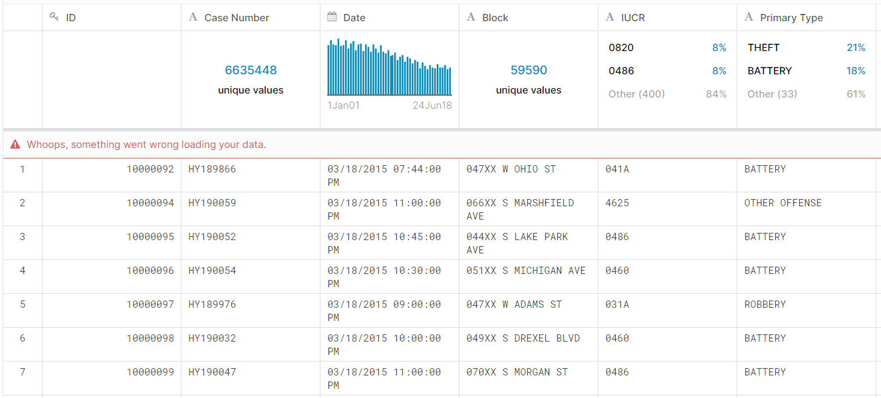

Data will be cleaned in order to find out which area was most affected and how was it reduced in the different years and what type of crime is most likely to occur is also analysed.